Hands-Free Reading
  - Preksha Ronak Shah, Han Luu, Lauren Durbin
  - 09/29/2026

GTA: Junyoung Kim
Lab Professor: Carla Zoltowski

Design Document
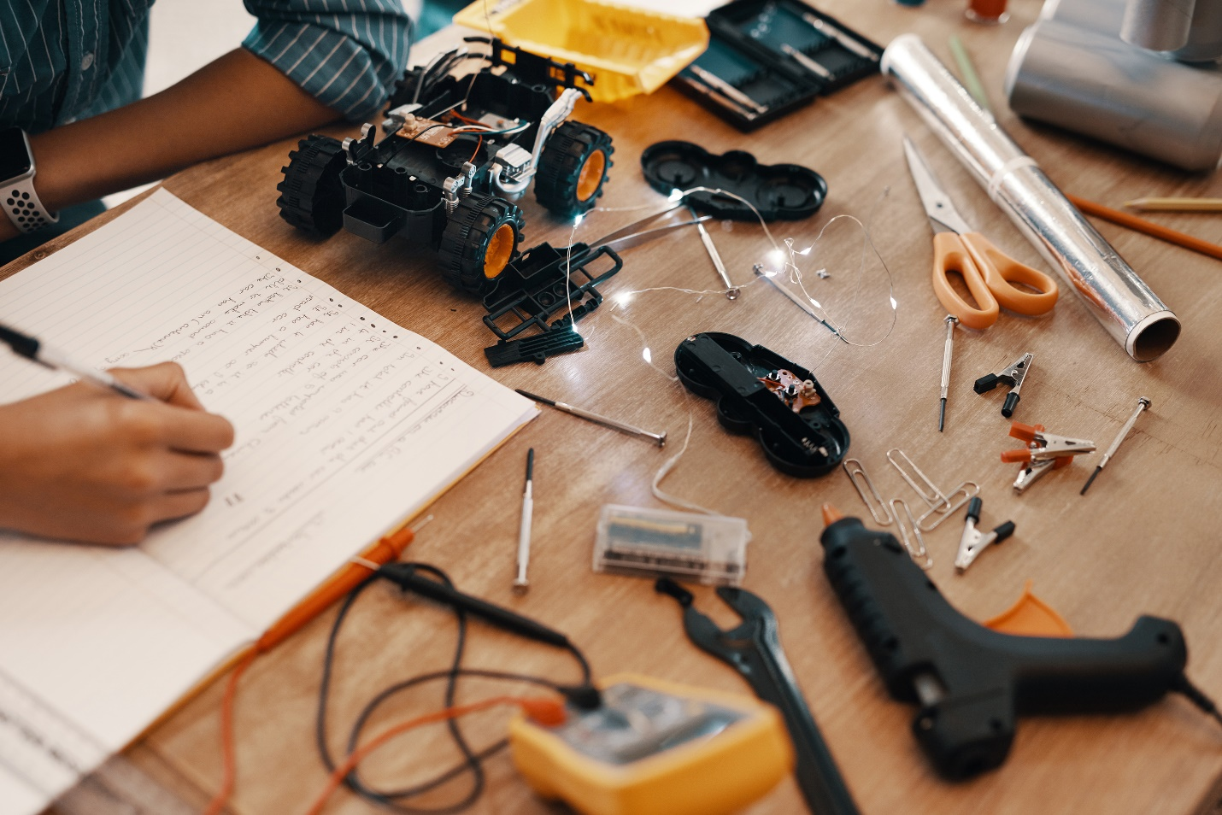
Figure 1: [Caption]

Introduction 6
Executive Description 6
Design Requirements 6
Requirements 6
Factors influencing requirements 6
Public Health, Safety, and Welfare 6
Global Factors 6
Social Factors 6
Environmental Factors 7
Economic Factors 7
System Overview 7
Functional Block Diagram 7
System Block Diagrams 8
System Activity Diagram 9
System Mechanical Design (Extra Credit) 9
Integration Approach 9
System Photographs 9
Subsystems 10
Subsystem 1: Vision 10
Subsystem Diagram 10
11
11
11
11
11
11
11
11
Specifications 11
Subsystem Interactions 12
Core ECE Design Tasks 12
Schematics 13
Parts 13
Algorithms 14
Theory of Operation 14
Specification Measurements 15
Standards 15
Subsystem 2: Robotics 16
Subsystem Diagram 16
Specifications 16
Subsystem Interactions 16
Core ECE Design Tasks 16
Schematics 17
Parts 17
Algorithms 17
Theory of Operation 17
Specification Measurements 17
Standards 18
Subsystem 3: Power 18
Subsystem Diagram 18
Specifications 18
Subsystem Interactions 18
Core ECE Design Tasks 18
Schematics 19
Parts 20
Algorithms 20
Theory of Operation 21
Specification Measurements 21
Standards 21
Subsystem 4: Display 22
Subsystem Diagram 22
Specifications 22
Subsystem Interactions 22
Core ECE Design Tasks 22
Schematics 23
Parts 23
Algorithms 23
Theory of Operation 23
Specification Measurements 23
Standards 23
PCB Design 24
PCB Schematics 24
PCB Layout 24
Final Status 24
Team Structure 24
Team Member 1 24
Team Member 2 24
Team Member 3 24
Bibliography 25
Appendices 26
Appendix A: [NAME] 26

Executive Description 6
Design Requirements 6
Requirements 6
Factors influencing requirements 6
Public Health, Safety, and Welfare 6
Global Factors 6
Social Factors 6
Environmental Factors 7
Economic Factors 7
System Overview 7
Functional Block Diagram 7
System Block Diagrams 8
System Activity Diagram 9
System Mechanical Design (Extra Credit) 9
Integration Approach 9
System Photographs 9
Subsystems 10
Subsystem 1: Vision 10
Subsystem Diagram 10
11
11
11
11
11
11
11
11
Specifications 11
Subsystem Interactions 12
Core ECE Design Tasks 12
Schematics 13
Parts 13
Algorithms 14
Theory of Operation 14
Specification Measurements 15
Standards 15
Subsystem 2: Robotics 16
Subsystem Diagram 16
Specifications 16
Subsystem Interactions 16
Core ECE Design Tasks 16
Schematics 17
Parts 17
Algorithms 17
Theory of Operation 17
Specification Measurements 17
Standards 18
Subsystem 3: Power 18
Subsystem Diagram 18
Specifications 18
Subsystem Interactions 18
Core ECE Design Tasks 18
Schematics 19
Parts 20
Algorithms 20
Theory of Operation 21
Specification Measurements 21
Standards 21
Subsystem 4: Display 22
Subsystem Diagram 22
Specifications 22
Subsystem Interactions 22
Core ECE Design Tasks 22
Schematics 23
Parts 23
Algorithms 23
Theory of Operation 23
Specification Measurements 23
Standards 23
PCB Design 24
PCB Schematics 24
PCB Layout 24
Final Status 24
Team Structure 24
Team Member 1 24
Team Member 2 24
Team Member 3 24
Bibliography 25
Appendices 26
Appendix A: [NAME] 26

Revision Log
Date | Revision | Changes
8/28/2026 | v0.1 | Initial Release
9/29/2026 | v1.1 | Design Document 1
10/18/2026 | v1.2 | Design Document 2
11/03/2026 | v1.3 | Updated Design Document Template
11/07/26 | v1.4 | Design Document 2 Update, Design Document 3

Introduction

Executive Description
Our project is a solution that allows users to read a physical paper book without using their hands. The solution consists of a vision component and a robotic component. The vision component will be used to track the user’s eye movement to determine when they are ready for the next page, and the robotic component will be used to flip the page for the user when ready.
This is in a fake reference [1]

Design Requirements

Requirements
- Orientation – Product usable when placed upright on a flat surface.
- Page Handling – Turning mechanism should not damage (scratch or tear) the pages
- Compatibility – System needs to work with a compatible book type
- Mostly hands-free - The user needs to be able to use the product entirely hands-free aside from the initial setup of the book on the holder.
- Easy to use and set up
- Portable – Product needs to be rechargeable and does not constantly need to be plugged in
- To be used in environment with standard lighting

Factors influencing requirements

Public Health, Safety, and Welfare
- A stable product is less likely to tip over or move unexpectedly during use. It also allows someone with limited hand/arm function to use it without needing to continuously stabilize it.
- An intuitive and easy-to-use design reduces the risk of improper operation that could create electrical or mechanical safety hazards.
- Careful consideration of the intensity and duration of emitted infrared (IR) radiation helps minimize potential risks to the user’s eyes from prolonged exposure.

Global Factors
- Using a USB-C charging port improves the product's global usability because USB-C is a widely adopted charging standard. Users can charge the device using commonly available USB-C power adapters rather than the product consisting of a proprietary, region-specific charger.

Social Factors
- A product that is mostly hands-free supports accessibility and independence for users with limited hand or arm function.
- Users with limited mobility should not need complicated physical manipulation to operate the device.

Environmental Factors
- The product is only designed to be used in indoor environments on stable, flat surfaces where lighting is sufficient. This will provide the optimal condition for the product to function as expected.
- Rechargeability can reduce reliance on disposable batteries.

Economic Factors
- The initial cost of the product should be as low as possible to make it more accessible to those it would benefit.
- Preventing damage to the user's books avoids replacement costs. It also makes the product practical for books that may be expensive, borrowed, or personally important.
- Rechargeability means the user does not need to spend money on buying replacement batteries.

System Overview
The system consists of three subsystems: vision, robotics, and power. The vision subsystem tracks the user’s eye movements to determine when the user is ready for the next page to trigger the robotic subsystem. The robotic subsystem flips the page for the user. The power subsystem handles the powering of all components and the rechargeable nature of the product.

Functional Block Diagram
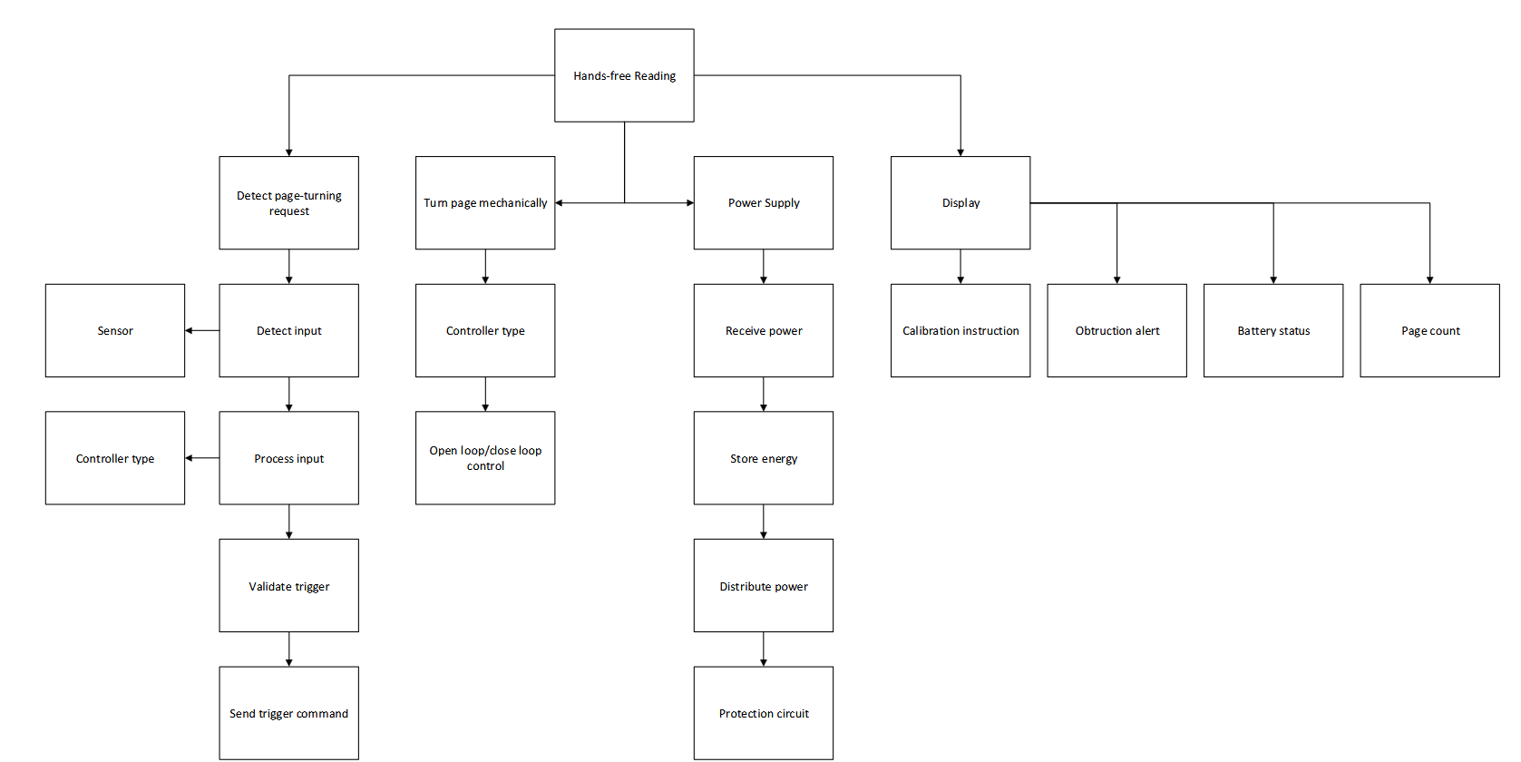

System Block Diagrams
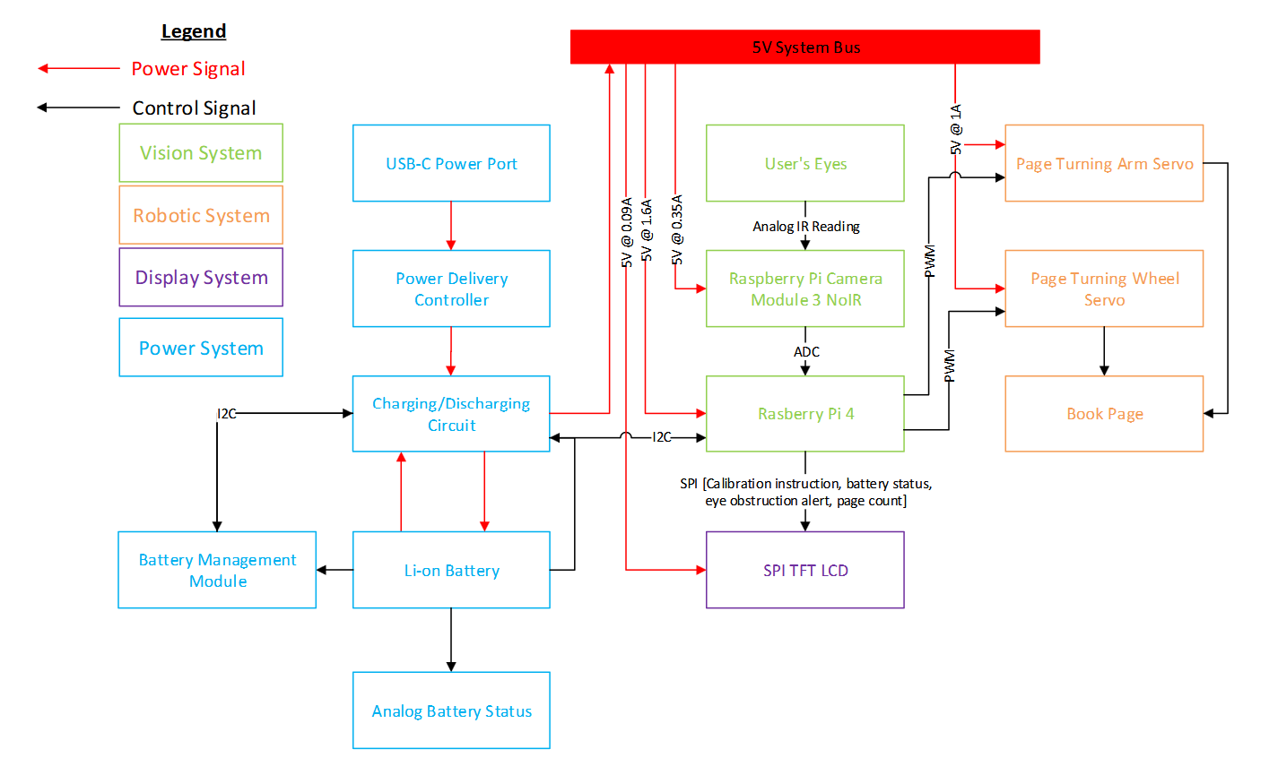

System Activity Diagram
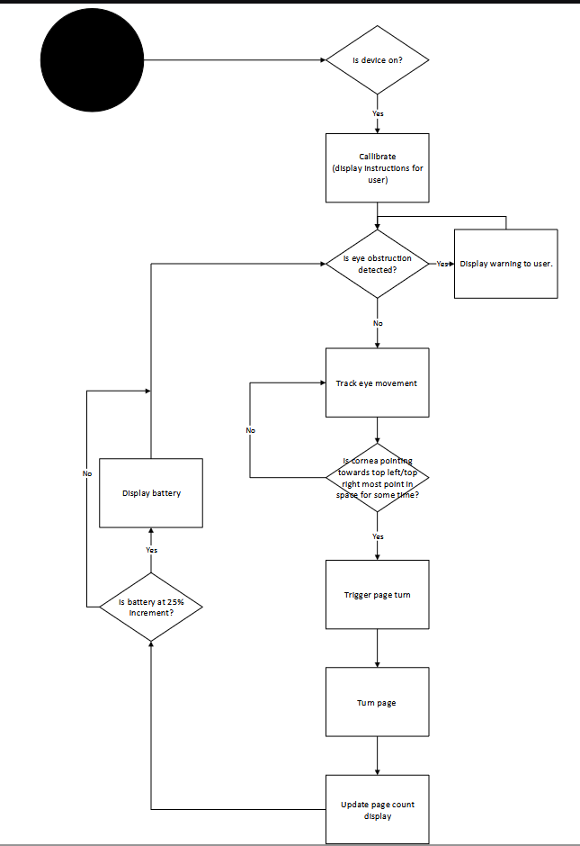

System Mechanical Design (Extra Credit)
[Design Document 4]

Integration Approach
[Design Document 4] [Theory behind the system design, with reference to subsystem integration within your system]

System Photographs
[Design Document 4]

Subsystems

Subsystem 1: Vision

Subsystem Diagram
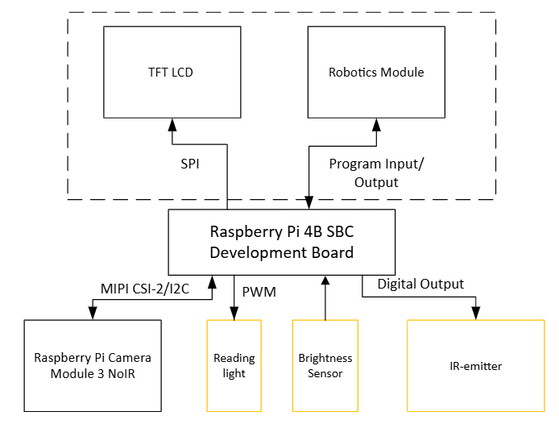

Figure 2: Blocks highlighted in yellow maybe added


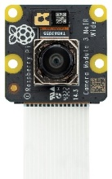
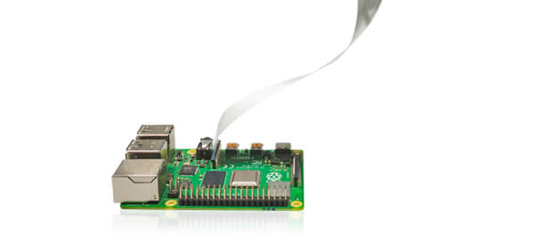

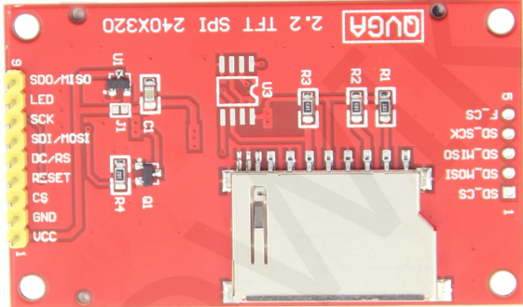

Specifications
- The subsystem shall generate three possible command states: forward, backward, or no page-turn request.
- The subsystem shall complete a successful calibration within 180 seconds of initiation.
- The user shall be able to request recalibration whenever the device is powered on. Calibration shall begin only when the page-turning mechanism is safely idle.
- The subsystem shall correctly recognize at least 90% of intentional forward and backward requests when the user's eyes are between 0.25 and 0.35 m from the camera and when eye-level illuminance is between 200 and 500 lux.
- The subsystem shall prevent new page-turn commands while the motor-control subsystem is executing a page turn.
- Calibration shall establish distinguishable neutral, forward-trigger, and backward-trigger gaze regions. Calibration shall be rejected and restarted if these regions cannot be reliably distinguished.
- The subsystem shall issue a page-turn command after 5 seconds of valid sustained gaze in the corresponding trigger region, allowing a defined tolerance for brief tracking interruptions like the user blinking their eyes.
- The subsystem shall generate no more than one unintended page-turn request per 30 minutes of normal reading under specified test conditions.
- The subsystem shall notify the user when valid eye tracking is unavailable continuously for more than 3 seconds (ex. The user's eyes are obstructed by a hat or hair).
- Following completion of a page turn, the subsystem shall require the user's gaze to return to the neutral region before accepting another request.
- If motor completion is not confirmed before a defined timeout, the subsystem shall inhibit additional commands until the fault is resolved.

Subsystem Interactions
Within the program loaded on the Raspberry Pi 4b, the eye tracking module sends one of three signals to the motor control module: turn a page backwards, forwards, or don't turn a page at all. Based on testing, if a brightness sensor and a reading light are required, the eye tracking module will control the intensity of the reading light using PWM based on how dark the environment is. If an IR sensor is used, the eye tracking module may control its periodic illumination using digital output pin. The raspberry pi 4b board along with camera and any other sensors/emitters (IR light, brightness sensor, reading light) will be powered by the power subsystem. During the setup phase, the eye tracking module will display calibration instructions on the TFT LCD for the user to follow using SPI protocol. During the general eye-tracking phase, the eye tracking module may display a warning to the user if their eyes are obstructed. The NoiR camera module 3 captures images periodically (at a fast enough rate) for the eye tracking function to process.

Core ECE Design Tasks
ECE 20875 – Python for Data Science: Experience with Python programming, Bash scripting, and existing libraries and modules will be valuable for developing the eye-tracking algorithm and navigating Raspberry Pi OS, a Debian-based Linux operating system.
ECE 26400 – Advanced C Programming: Experience programming in a Linux environment and managing files will be useful when working with Raspberry Pi OS. Programming fundamentals will also support image processing using the Raspberry Pi Camera Module 3.
ECE 36200 – Microprocessor Systems & Interfacing: Knowledge of computer architecture and interfacing with external peripherals will be useful for integrating the Raspberry Pi 4B with the camera and potential additional sensors, such as a brightness sensor.
ECE 20008 – Electrical Engineering Fundamentals II Lab: The final laboratory project involved designing circuits with an IR emitter and receiver for pulse-rate detection. This experience provides a foundation for integrating an IR emitter into the eye-tracking subsystem, if required.

Schematics
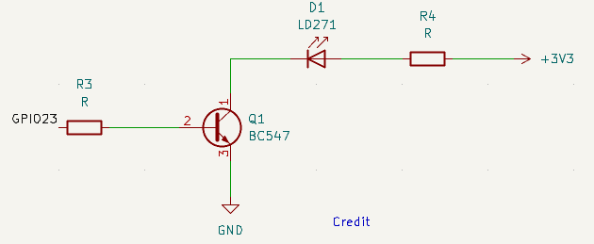
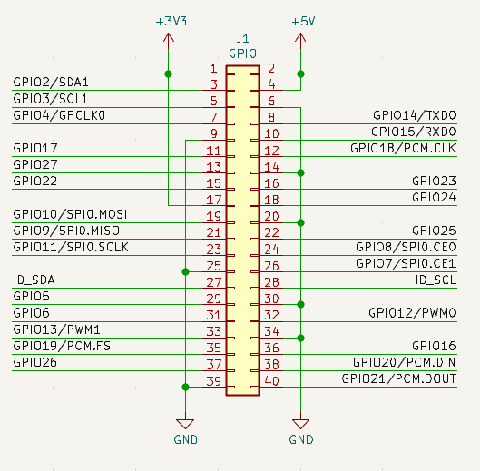
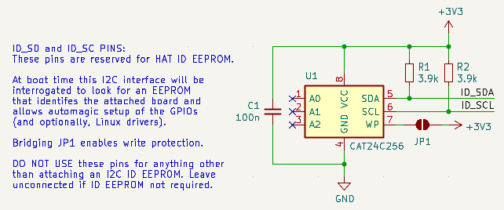
[Design Document 4] [image]
Figure 3: IR emitter connection (Potentially)
Figure 4: 40-Pin GPIO header pinout of Raspberry Pi 4b
Figure 5: Do not modify
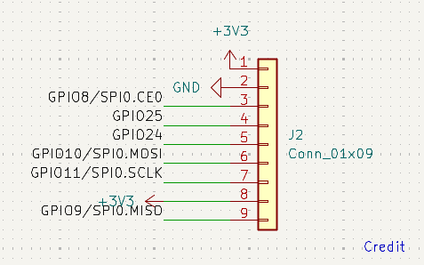
Figure 6: SPI TFT Module Connections

Parts
- Raspberry Pi Camera Module 3 NoIR - $27.50
- Raspberry Pi 4 Module B 2GB - $67.50
- 2.2-in. SPI TFT LCD with SD card support (ECE 362 Kit - free)
- Jumper Wires
- Use brightness sensor on smartphone
- Micro-HDMI to HDMI cable (ECE shop - free)
- 8 GB Micro-SD Card (ECE shop - free)
- 32 GB Micro-SD Card (ECE 362 Kit - free)
- 3D Printed case and mounting (Bechtel/Purdue Library – free/free up to 50 grams)
- IR emitter (Potentially)
- Intensity-controlled reading light (Potentially)
- Brightness sensor (Potentially)
[Design Document 6][Finalized List]

Algorithms
[Design Document 4]
(With no brightness sensing and reading light control or IR emitter)
Calibration phase
- Inform the user that calibration is beginning and provide four seconds to prepare.
- Instruct the user to look toward the center of the book. Allow two seconds for adjustment and record the normalized eye position for three seconds.
- Instruct the user to look toward a comfortable point beyond the book's upper-right corner. Allow two seconds for adjustment and record for three seconds.
- Repeat the procedure for the upper-left gaze position.
- Validate that the three recorded gaze regions can be reliably distinguished. If validation fails, repeat calibration.
- Inform the user that calibration is complete.
- Permit recalibration using the calibration button whenever the mechanism is safely idle.
Eye-tracking phase
- Continuously capture camera frames and estimate normalized gaze direction.
- Classify the current gaze as neutral, forward, backward, or unknown.
- If the user's gaze enters a calibrated page-turn region, initiate a five-second dwell timer.
- Continue monitoring the gaze throughout the dwell interval. Reset the timer if the user moves outside the selected region, switches direction, or tracking becomes unreliable beyond the permitted tolerance.
- If the user maintains a valid gaze for five seconds, register one page-turn request.
- Disable additional page-turn requests and transmit the command to the motor controller.
- Wait for motor completion or a timeout/failure response.
- Following successful completion, require the user to return to the neutral gaze region before rearming the eye-tracking subsystem.
- If a motor fault or timeout occurs, prevent new commands until the fault is safely resolved.
- Resume normal gaze detection once the system is rearmed.

Theory of Operation
[Design Document 4]
Case 1 : Visible Light (Passive Illumination)
A camera continuously captures images of the user's eyes at a specified frame rate. Ambient visible light illuminates the eyes, allowing the camera to distinguish anatomical features such as the iris, sclera, eyelids, and eye corners.
Image-processing algorithms identify the boundaries of the iris and estimate its center within each detected eye region. The position of the iris center relative to reference landmarks, such as the inner and outer eye corners, is then used to estimate the user's gaze direction. Using relative coordinates rather than absolute image coordinates helps reduce sensitivity to changes in the user's position within the camera frame.
Because this approach relies on ambient visible light, its performance may be affected by changes in illumination, shadows, reflections from eyeglasses, partial obstruction of the iris by the eyelids, and movement of the user's head relative to the camera.
Case 2 : Infrared/near infrared (Active illumination)
Two commonly used infrared illumination configurations are bright-pupil and dark-pupil tracking, which differ primarily in the position of the illumination source relative to the camera's optical axis.
Bright-Pupil Tracking: When the infrared illumination source is positioned approximately coaxially with the camera's optical axis, a portion of the light enters the pupil, is reflected or scattered by structures at the back of the eye, and returns toward the camera. This produces a bright-pupil appearance, similar to the red-eye effect observed in photographs captured using a flash camera. This creates a contrast between the bright pupil and the surrounding iris for pupil detection and tracking.
Dark-Pupil Tracking: When the infrared illumination source is positioned away from the camera's optical axis, most of the light returning from the back of the eye is directed away from the camera. Consequently, the pupil appears relatively dark compared to the surrounding portion of the eye. Image-processing algorithms can identify the pupil boundary and estimate its center.

Specification Measurements
[Design Document 4][Every specification above should be validated with measurements]

Standards
[Design Document 4][Expected]
- [Standard Name]: [explain the connection to the project]
[Design Document 6][Finalized]

Subsystem 2: Robotics

Subsystem Diagram
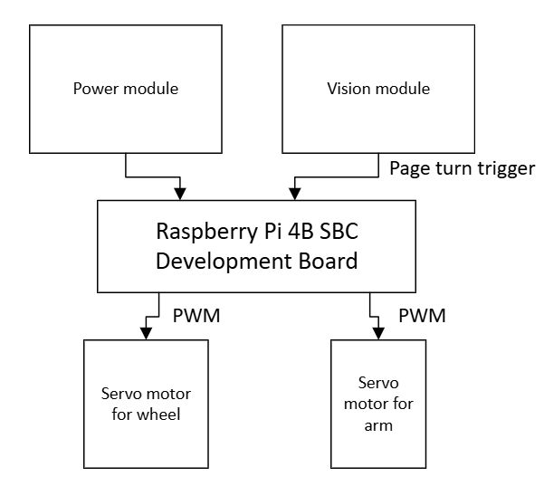

Specifications
- The robotics subsystem should turn only one page at a time.
- The robotics subsystem should hold the turned pages down.
- The robotics subsystem should not damage the book in any way (tears, folds, scratches, etc).

Subsystem Interactions
The actions of the robotics subsystem are triggered by the vision subsystem and powered by the power subsystem.

Core ECE Design Tasks
ECE 20008: This course is useful for this task as it taught the basics of motor control and PWM, and this knowledge will be applied to the design of the motor control and the specific motor movements.
ECE 36200: This course is useful for this task as it taught the use of PWM with microcontrollers, and this knowledge will mainly be applied to how the subsystem communicates with and controls the motors.

Schematics
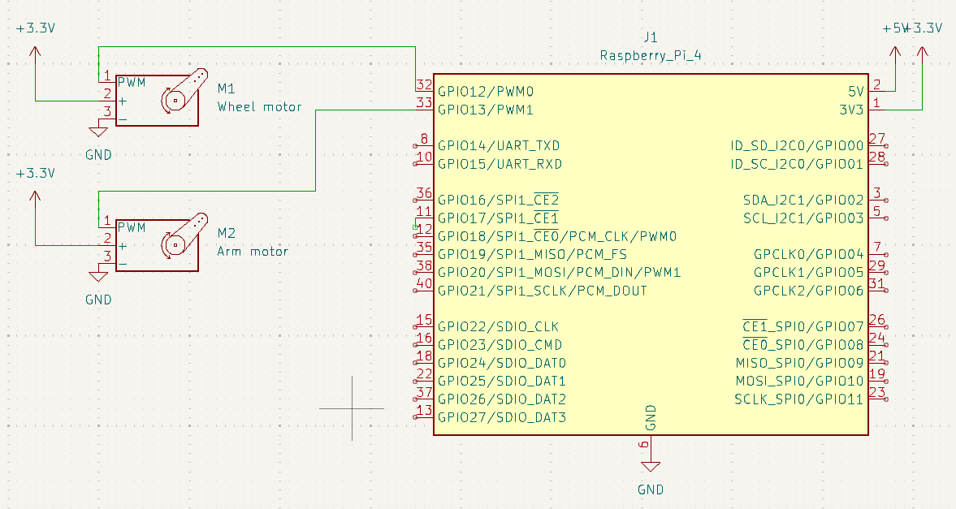

Parts
- 2 servo motors (Look for in ECE shop)
- Page turning arm (3D print)
- Servo wheel - $3.48
[Design Document 4][Finalized List]

Algorithms
- Robotics subsystem receives page turning trigger from vision subsystem
- Robotic subsystem triggers wheel motor with no delay and arm motor with ~0.5 second delay
- Wheel motor completes one full rotation to lift page
- Arm motor completes one quarter rotation to hold lifted page down
- Robotic subsystem triggers continuation of vision subsystem

Theory of Operation
The robotic subsystem uses two different servo motors for the function of turning a page. The first motor is connected to a wheel which will rotate to lift the page from the book. The second motor is connected to a set of arms that rotate to hold down the lifted page. The timing of the actuation of these motors needs to be controlled so they work together to successfully flip a page without damaging it. PWM is the main form of control for this. PWM sends a square wave with a specified high time to control the angle of the motor. The wheel motor will need one rotation to lift up the page, and the arm motor will need one quarter rotation to hold the page down. The function of the arm motor needs to be delayed slightly from that of the wheel motor so the page is lifted enough for the arm motor to catch. This timing will be determined experimentally as it depends on several factors such as environment, page thickness, and page finish.

Specification Measurements
[Design Document 4][Every specification above should be validated with measurements]

Standards
[Design Document 4][Expected]
- IEEE 3004.8: IEEE Std 3004.8-2016 is an active IEEE recommended practice that provides comprehensive guidelines for selecting and applying motor protection schemes in industrial and commercial power systems.
[Design Document 6][Finalized]

Subsystem 3: Power

Subsystem Diagram
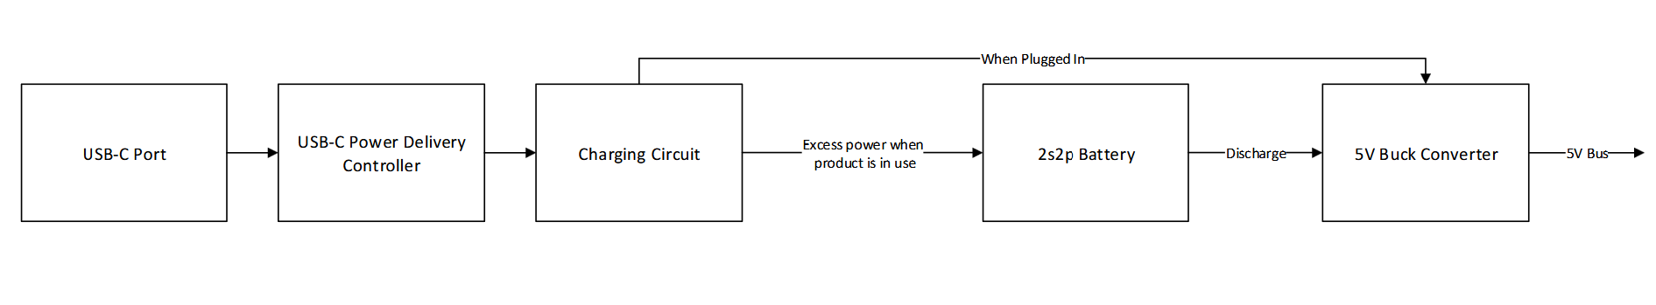

Specifications
- 2s2p Samsung INR217 battery pack providing up to 73Wh or approximately 5 hours of discharge
- Voltage input: 4.1V or 22V
- Voltage output: 5V
- Rated current: 5A

Subsystem Interactions
Power module will provide a 5V power signal produced by the buck converter to power the camera module (vision subsystem), the servos (motion subsystem), and the Raspberry Pi (controller). Apart from that, an I2C signal is going to be sent from the charging circuit to the Raspberry Pi to communicate battery status and telemetry monitoring.
Even though hardware will provide and analog protection layer with embedded within the LTC4162 and the primary overcurrent protection chip (model to be determined), the Pi will support a software limit, allowing more effective fault control and identification.

Core ECE Design Tasks
ECE 20001/7: The system utilizes a lot of the fundamental to electrical engineering knowledge as we need to ensure that voltage sources are not conflicting and that we are delivering enough power to the rest of the circuit.
ECE 20002/8: These classes enable more control over the flow of electricity by using mosfets to analogically control how the battery is going to get charged and discharged.
ECE 362: The design aspect of 362 project also helps with system familiarity as the project also utilizes battery and kicad for designing

Schematics
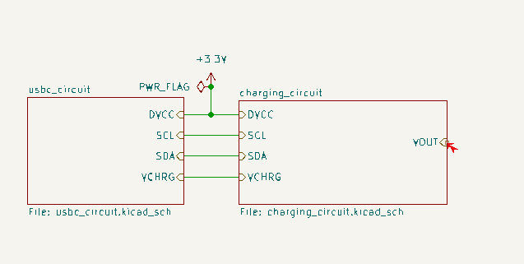
Figure 1: Root
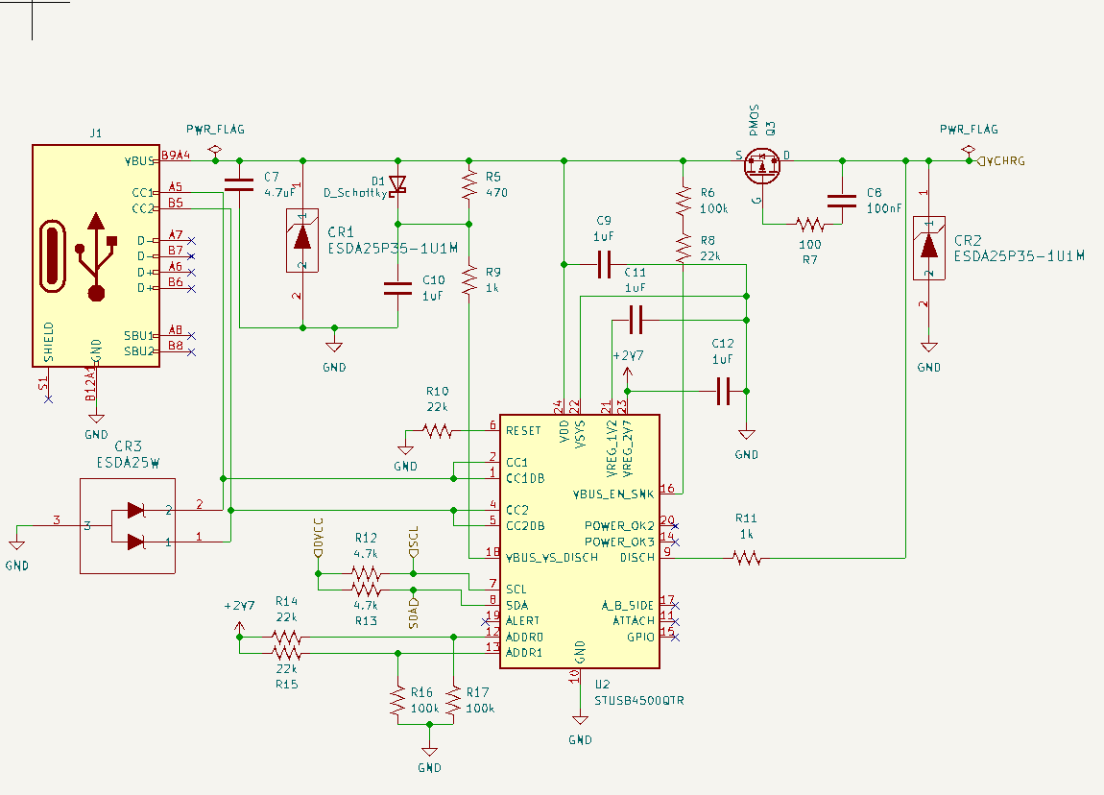
Figure 2: usbc_circuit

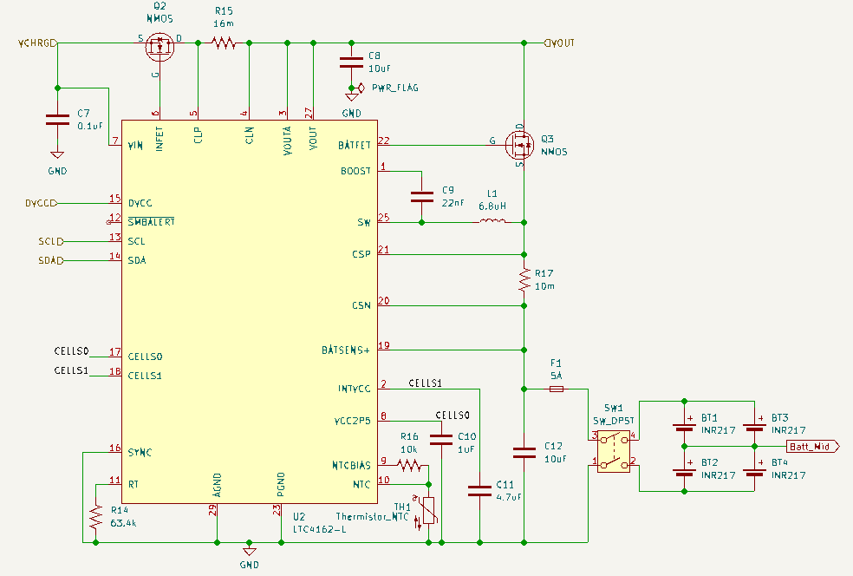
Figure 3: charging_circuit
Figure 4: buck_converter (To be added)
Figure 5: Primary Protection Circuit (To be added)

Parts
- Li-ion charge management controller: MCP73831-2-OT: link: $0.76x5
- Li-ion battery (undecided on capacity)
- LDO: XC6220B331MR: link: $0.98x5
- General parts (to be found in ECE shop):
  - USB-C port
  - PMOS for power selection
  - Decoupling capacitors
  - Resistors
[Design Document 6][Finalized List]

Algorithms
The power supply module takes power from USB-C Power Delivery (PD) controller to supply the system and charge a 2S2P Li-ion pack with the leftover power. The module switches system power to battery source when external source from PD is removed. The hardware does the charging and discharging and status signals are sent to PI through I2C for reporting.
1. Input negotiation (STUSB4500)
2. Source selection (LTC4162 PowerPath)
3. Charging profile (LTC4162)
4. Protection (Not added yet, consider optional)
5. Supervision (Pi over I2C)

Theory of Operation
There are 2 main states of concerned: Charging and discharging. Once turned on, the battery management system is going to continuously monitor and check thebsattery states to ensure 4 of these faults are not occurring: Overvoltage, undervoltage, overcurrent, and overheat

Specification Measurements
[Design Document 4][Every specification above should be validated with measurements]
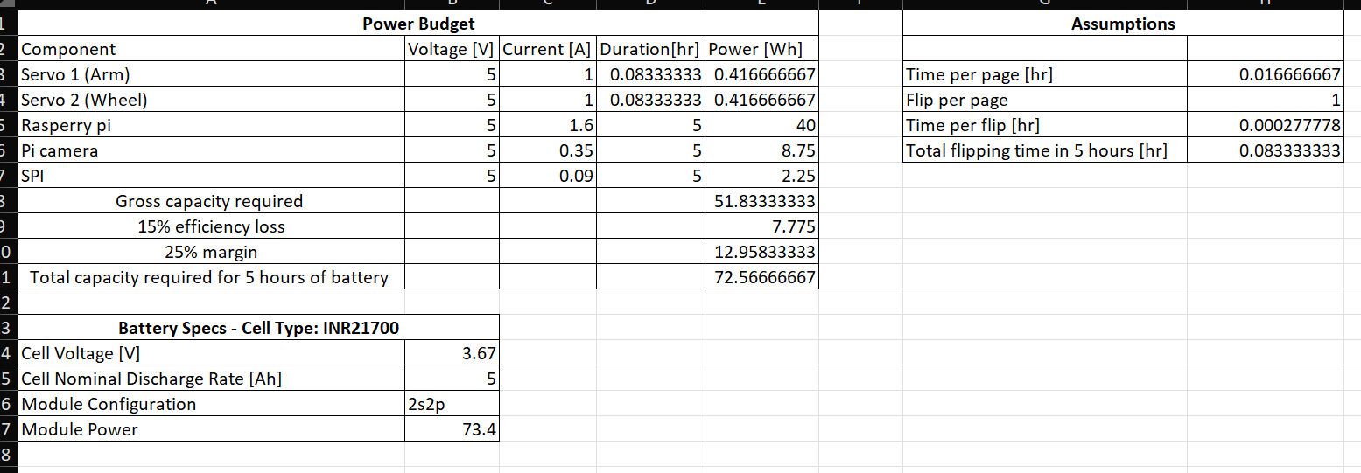

Standards
- IEEE 1625: IEEE 1625 is an Institute of Electrical and Electronics Engineers (IEEE) standard for the design, quality, and safety of rechargeable lithium-ion and lithium-ion polymer battery systems used in multi-cell mobile computing devices like laptops
[Design Document 6][Finalized]

Subsystem 4: Display

Subsystem Diagram
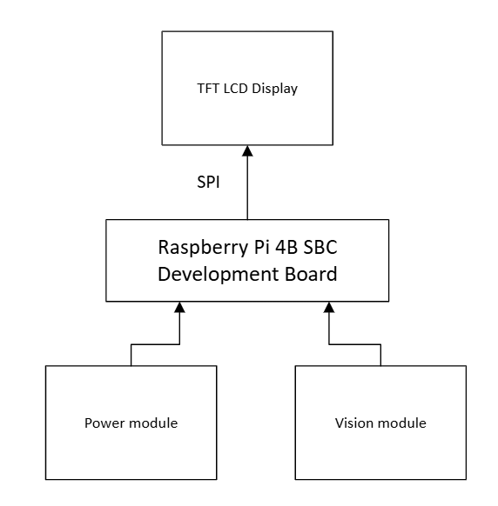

Specifications
- Display calibration process instructions to user.
- Display battery charge update every 25%.
- Alert user if an eye obstruction is detected and the system is unable to track eye movement.
- Display page count to user.

Subsystem Interactions
This subsystem is powered by the power subsystem, and it receives information from both the power and vision subsystems.

Core ECE Design Tasks
ECE 36200: Provided knowledge of interrupts, GPIO, and SPI which will be useful in this application for sending information to the display and displaying the actual information.

Schematics
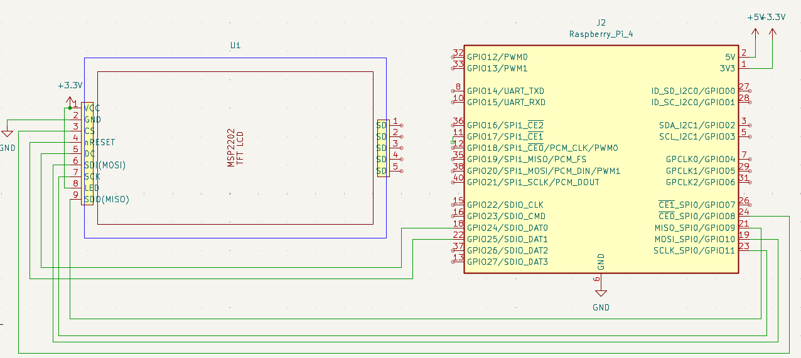

Parts
- TFT LCD display
[Design Document 4][Finalized List]

Algorithms
- Wait for interrupt from vision or power subsystem
- Upon page turn interrupt from vision system, update and display page count
- Upon eye obstruction interrupt from vision system, display error text message
- Upon calibration interrupt, display text calibration instructions

Theory of Operation
Interrupts allow the system to continue working on tasks until a specific event occurs instead of constantly polling to check if that event occurred. When an interrupt request is made, the system pauses where it is in the main program and executes the handler for whatever event happened then returns back to the main program. Several interrupts can happen at the same time, and which gets executed first depends on priority, but all get executed before the system returns to the main program. These interrupts will be configured and used to alert the display subsystem when it needs to display something new. SPI is a communication protocol which will be used to display the actual information as it allows reading and writing to devices.

Specification Measurements
[Design Document 4][Every specification above should be validated with measurements]

Standards
[Design Document 4][Expected]
[Design Document 6][Finalized]

PCB Design

PCB Schematics
[Design Document 4]

PCB Layout
[Design Document 5]

Final Status
[Design Document 6]

Team Structure

Team Member 1
Preksha Ronak Shah
Contact: shah880@purdue.edu
Team Role: External Communication
Major: Electrical Engineering
Bio: I am a fourth-year Electrical Engineering student at Purdue University with experience in embedded systems, PCB design, sensors, and microcontrollers. I am interested in applying my technical experience to this project while developing new skills in robotics and computer vision. I hope to contribute to creating a practical and accessible device that allows users to interact with physical books more independently.

Team Member 2
Lauren Durbin
Contact: durbin7@purdue.edu
Team Role: Internal Communication
Major: Electrical Engineering
Bio: I am a senior in Electrical Engineering at Purdue, and I have concentrations in AI/ML and Automatic Control. I am interested in working in an automation or controls role following graduation, and some components of this project align with that. I have experience with machine and computer vision from previous internship experiences and am currently in an introductory robotics course, and I expect to apply all of this knowledge to this application.

Team Member 3
Han Luu
Contact: luum@purdue.edu
Team Role: Purchasing
Major: Electrical Engineering
Bio: I’m a senior in Electrical Engineering and interested in power systems. I have had internship experience in power systems as well as handling DC high-voltage lines for my club, so I am comfortable to be a primary contributor to the charging component of this project as well as helping out with the robotics component.

Bibliography
[1] | Beasley, "ECE 49022 Fake Artical," Beasley Centenial, vol. 1, no. 2, p. 3, 2050.

Appendices
[This section is mainly designed for code. You can directly generate a somewhat decent display of your code file or psuedo code by using the template provided below. You can have as many appendix as you want. In the document, you can refer to the code posted here instead of pasting the whole code in the body.]

Appendix A: [NAME]
[Insert code]

